Essential Information for Hirers of Poppleton Tithe Barn

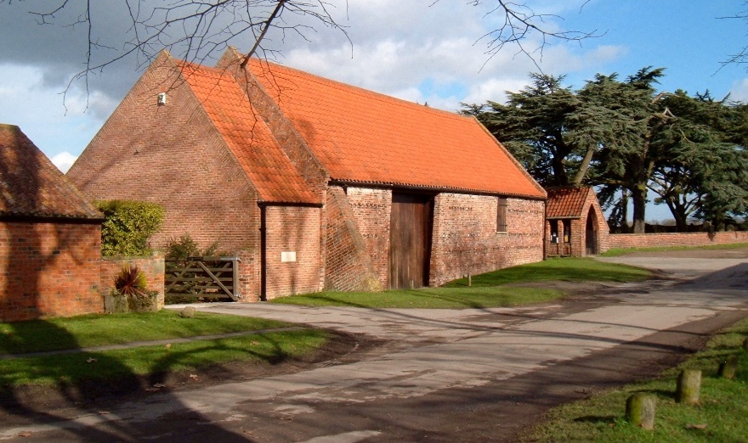

Background

Poppleton Tithe Barn is an historic building initially constructed in the sixteenth century to collect tithes following the dissolution of the monasteries. Tithes, agricultural produce, were effectively taxes paid to the Manor, a tenth of a tenant’s income.
By 1989 the Tithe Barn had become a dilapidated, Grade 2 listed, ‘Building at Risk.’ At this time the Friends of Poppleton Tithe Barn (Charity Number 1060767) was set up and restoration was completed in 2000. The Tudor Sensory garden behind the Barn was created in 2004. Further information is available on our website. poppletontitheBarn.co.uk
The charitable aims of the Friends of Poppleton Tithe Barn are to preserve the building and make it available for certain functions such as craft fairs, art exhibitions, meetings, talks etc. In addition to this we let out the Barn for private functions such as lunches, dinners and wedding breakfasts.

Plan of Tithe Barn

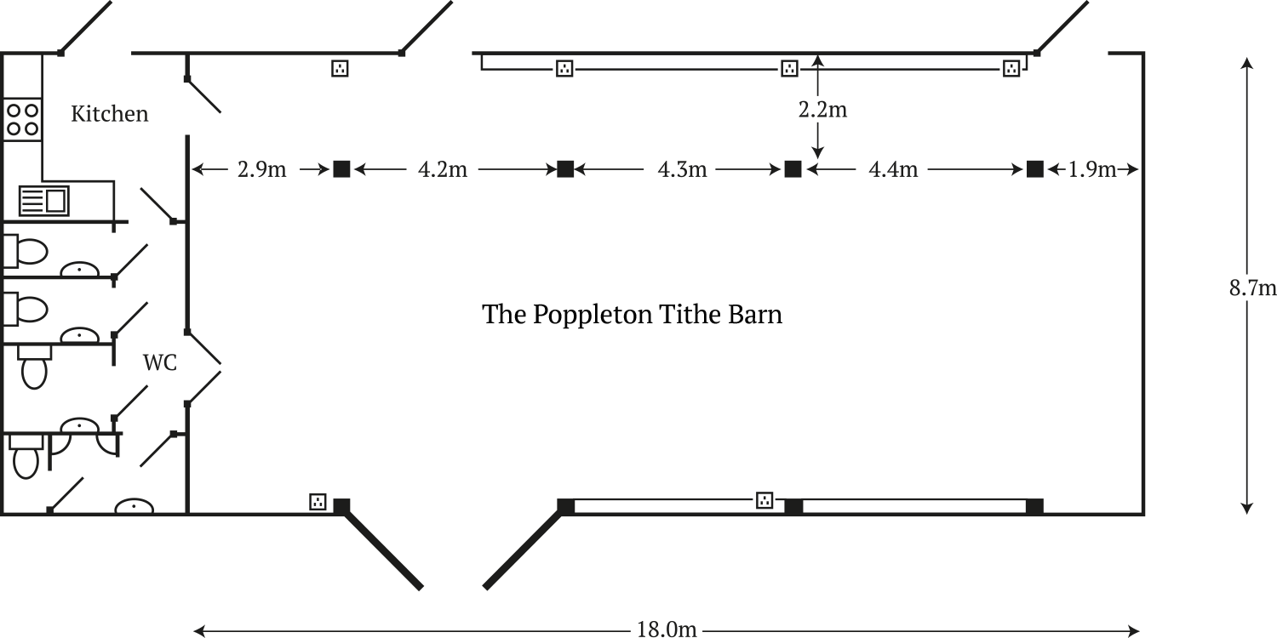

Facilities

We provide a venue that can cater for up to 90 people sitting in comfort around tables within the Barn. A maximum of 100 to 120 people can be accommodated if the side benches are used. We provide a variety of tables and chairs, including several round tables. A small, recently refurbished, modern kitchen is available including fridge, wine fridge, microwave, small cooker, hob and a water heater. Cutlery and crockery are also available.
Disabled access is available through the rear door and there is a disabled toilet.
Central heating is available but please be aware that the Barn may feel cold in the winter months (there are vents in the walls and the heating system has to create benign conditions due to the historic materials used in its construction). A heating surcharge (currently £30) will be added from 1st Nov to 30th April.
Tablecloths may be available on request for a charge (currently £3.50 each) towards laundry. Tablecloths are not provided for weddings.

Poppleton Tithe Barn is a wonderful venue with the benefit of a private garden, set in a picturesque conservation area including a twelfth century church (Saint Everilda’s), the Millennium Green, a village pond and a riverside park. However, all requests to hire the Barn must follow certain restrictions.

Restrictions of use

While we welcome enquiries from potential Hirers we need to make it clear at the outset that lettings are subject to certain restrictions. The Barn is situated very close to residential housing and is not insulated for sound. Noise therefore travels very easily through the fabric of the building into the surrounding area. In view of this we have come to an arrangement with local residents so that noise and disturbance are limited by frequency and by volume. In brief this means that private functions are restricted to two per month and no electronic amplification of any type is allowed. Musical events are also limited and are subject to restrictions and can take place by special arrangement only.

If your proposed event can fit in with the above restrictions and you would like to hire the Barn please read on…

Event Categories

At the time a booking is agreed the Booking Trustee will decide which category your event will be listed under. We divide lettings into three categories:
Category One events are those that have the potential to cause most disturbance to our neighbours. Any event including music is automatically listed as a Category One. Category One events include all weddings, and private functions where the capacity exceeds 60 people. We can list twelve of these per year in total.
Category Two events are private functions of less than 60 people, such as celebratory lunches and most christenings. We can list a further twelve per year.
Category One and Two events are usually celebratory events which are the type of event which it is agreed have the potential to cause the most disturbance to our neighbours.
Category Three events include all other listings.

Children’s parties are not allowed. We have to be mindful when accepting a booking if children attend any function, then we have to be sure that arrangements will be in place for their supervision. The Tudor Sensory Garden is not a suitable venue for children’s games and bouncy castles are not permitted.

Use of the Tudor Sensory Garden

The garden is primarily a place for quiet enjoyment and refection. Hire of the Barn includes use of the garden but furniture must not be removed from Barn and set up in the garden. Food and drink should be served from within the Barn. However, guests are welcome to stroll around the garden and it is also a good place for wedding photographs.

Music in the Barn

As mentioned, we are allowed to accept bookings that include music up to a maximum of 12 times per year. Any plans for music must be outlined and agreed with the Booking Trustee before an event is accepted.
No amplification of any type is allowed. This includes any ‘background’ music played on speakers via smart phones etc.
Experience has shown that the Barn is best suited for individuals or small groups singing or playing acoustic instruments such as a piano (available in the Barn), acoustic guitars, string quartets etc.
A maximum of 8 performers are allowed.
Brass bands and drum kits are not permitted.
The glass doors should be kept closed during performances.
Performances must not exceed a maximum of 3 slots of 20 minutes with breaks in between.
All music should end by 10pm.

Bond

For certain events, such as weddings, the Trustees require that the Hirer pays a Bond. The Bond is paid at the time the full amount of the hiring fee becomes due, six weeks before your event. The purpose of the Bond is to cover the unlikely event that extra costs might be incurred in relation to damage and any additional cleaning required – please note that Hirers are expected to vacate the Barn in the condition in which they found it including the cleaning of all surfaces and the removal of rubbish. However, in addition to the above, the Bond can also be retained, at the discretion of the Trustees, if any costs are likely to be pertained as a result of any breaking of the terms and conditions of the hire that might put future letting of the Barn at risk.

And finally

Please do not be put off by the above conditions. If your event fits the allowed categories and your event follows the terms and conditions of your booking then there is no reason that the Barn will not be a fabulous place to hold your event. All events are care-taken by an experienced Duty Trustee who will contact you a few weeks before your event, to finalise arrangements. They will arrange to meet with you at the Barn before your event and help make sure that your event runs smoothly and successfully. Please note that Trustees are unpaid volunteers and they will not be present throughout your event.

What Happens Next

If you wish to proceed with booking your event and a suitable date is available then you will be sent an application form. Please fill in all the details including maximum number of guests expected, catering arrangements etc. We can advise on caterers who have experience on using the Barn. If you would like to include music, subject to the above conditions, then it is essential that you give full details.
If your booking is accepted you will then be sent a contract to sign and return with your deposit. The contract will include all the terms and conditions of your booking. On receipt of the signed contract and deposit your booking will be confirmed.
Final payment will become due six weeks prior to your event. Any cancellation fees will be outlined in your contract.

On behalf of the Trustees of Poppleton Tithe Barn we hope that, if the conditions are right for your event, you will go ahead with your booking. As mentioned further information is available on our website and specific questions can be answered by email. If you would like to request a visit this can be arranged through one of our Duty Trustees.

Communication

- Via our website, poppletontithebarn.co.uk, communication page.

Booking Trustee: Melanie Kay on: 07388 927730 or
EMAIL: melanie.kay@picapica.co.uk

